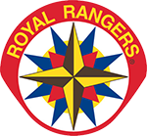 | SPD ROYAL RANGERS
 | For additional information please contact:
 | Contact:
 | Phone:
 | E-Mail:
CAMPOREE EQUIPMENT CHECKLIST

OUTDOOR CAMP CLOTHING |  | SUPPLIES | PERSONAL ITEMS (compact)
Uniform Encouraged (not required) |  | Small New Testament Bible | *Medications (read below)
3 Pants (Cargo recommended) |  |  | Toothbrush and Toothpaste
3 T-shirts (RR recommended) |  |  | Face Towel
4 Underwears |  |  | Deodorant
4 Pairs of Socks |  |  | Soap (Face Wash)
1 Sweatshirt with Hoodie |  |  | Tissue Paper
1 Warm Jacket (Rain Waterproof) |  | Water Bottle (Plastic or Metal) | Comb/Brush
Hat (RR recommended) |  | ~NOTE: You will need to bring drinking water | Shampoo/Conditioner
2 Pajamas (1 regular and 1 shorts) |  |  | Mosquito Repellant
2 Pairs of Swimming Shorts |  |  | 2 Large Towels (bathing and swim)
1 Pair of Sandals |  | Outdoor Camping Mess Kit ($15) | Sun Block
1 Extra Pair of Hiking Boots or sneakers |  | Cup, Plate, Bowl, Fork, Spoon, Knife
 |  | 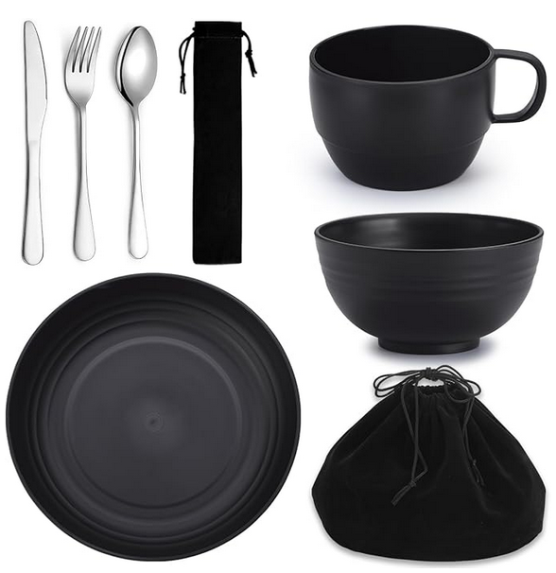 | Optional
CAMPING GEAR |  |  | Mouth Wash
Sleeping Bag |  |  | Lip Balm
Pillow |  |  | Disposable Water Poncho
Flashlight (Headlight recommended)
Optional |  |  | Personal First Aid Kit ($10)
Extra Warm Blanket (inside) |  |  | 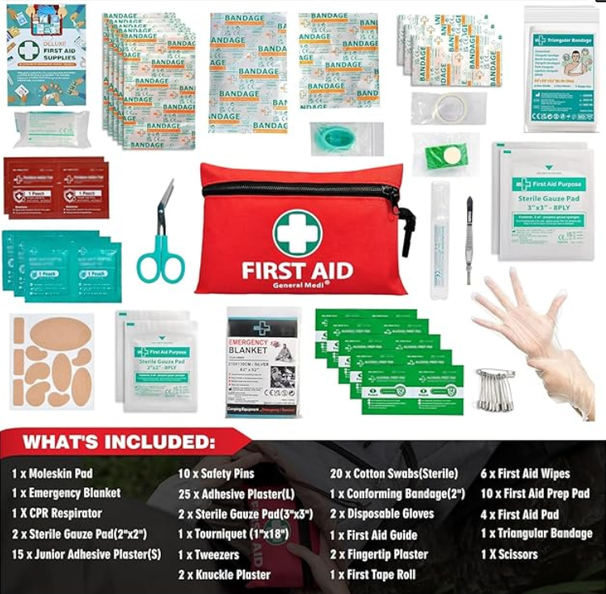
Pair of Hand Gloves (warm)
Beanie

 | *It's important to inform the leader about all medications, including those for conditions like asthma, allergies, and any other type of medication. This ensures that the leader is aware of any medical needs and can provide appropriate support if necessary. If you have any specific questions or need further assistance, feel free to ask!

